

FACULTY OF ENGINEERING AND TECHNOLOGY
BACHELOR OF TECHNOLOGY

Database Management System Laboratory
(303105204)

3rd Semester
Computer Science & Engineering Department
Laboratory Manual



CERTIFICATE

This is to certify that Mr. xxxxxxxxxxxx
with enrolment no. xxxxxxxxxxxx has successfully
completed his laboratory experiments in
Database Management System Laboratory
during the academic year 2025/26.

Date: Signature of lab teacher:

Signature of HOD:

INDEX
SR. NO. | TITLE | PAGE  NO. | PERFORMANCE DATE | ASSESSMENT DATE | MARKS | SIGN.
1 | DBMS Introduction & Implementation for Real-world Applications Using MS Office Excel.
2 | Table Creation & Data Insertion.
3 | BASIC SQL QUERIES:  Execute simple queries using SELECT, DESCRIBE, and display specific columns from tables.
4 | SQL WITH CONDITION:  Perform conditional queries like >, <, BETWEEN, IN.
5 | PATTERN MATCHING – LIKE OPERATOR:  Use LIKE with patterns in queries on names, pin codes, and city patterns.
6 | AGGREGATE FUNCTIONS & DML OPERATIONS:  Use aggregate functions and DML to update data
7 | JOIN OPERATIONS:  Perform join queries for sailors, boats, employees with filters and multi-table joins.
8 | JOIN OPERATIONS:  Advanced join queries with filters, group by, and client/product relationships.
9 | MISCELLANEOUS SQL TASKS:  Advanced tasks: Date ops, region filtering, price ranges, subqueries, etc.
10 | PL/SQL PROGRAMMING:  Write PL/SQL blocks: addition, area, max of 3, loops, Fibonacci.

PRACTICAL NO: 1

AIM: DBMS Introduction & Implementation for Real-world Applications Using MS Office Excel.

- What is DBMS? Explain the advantages of DBMS over FPS.

DBMS stands for Database Management System. DBMS helps to maintain the data in tables and records, which is more systematic than FPS (File Processing System).

The advantages of DBMS over FPS are as follows:
- Data redundancy and inconsistency
- Data sharing
- Data concurrency
- Data searching
- Data integrity
- Data security
- Data backup
- Easy maintenance

- List 15 applications of databases. Explain how databases can be helpful in managing any 2 of these applications.

The 15 applications of the Database are follows:
- Banking
- School (Students & Staff’s Details)
- Human Resources Management
- Manufacturing Sector (Product Details)
- Supermarket
- Library
- Railway Reservation System
- Credit Card Exchange
- Social Media Services
- Airline Reservation System
- Healthcare Sector
- Online Shopping
- Agriculture Fields
- Telecommunication Sector
- Military Purpose.
Railway & Airline Reservation System:
It keeps the records of ticket bookings, arrival time, departure time, time delay, and even the seat no. of the airplane or train.

Library Management System:
There are thousands of books in the library, so it is very important to keep are cord of the details of each book. Hand written records can be proven are alhassle when we have to manage large no of books, using DBMS all the details of each book such as name, author’s name, number of pages, availability, quantity, etc., can be managed productively.

- Create the Database for the following:

- Student Details using Excel:

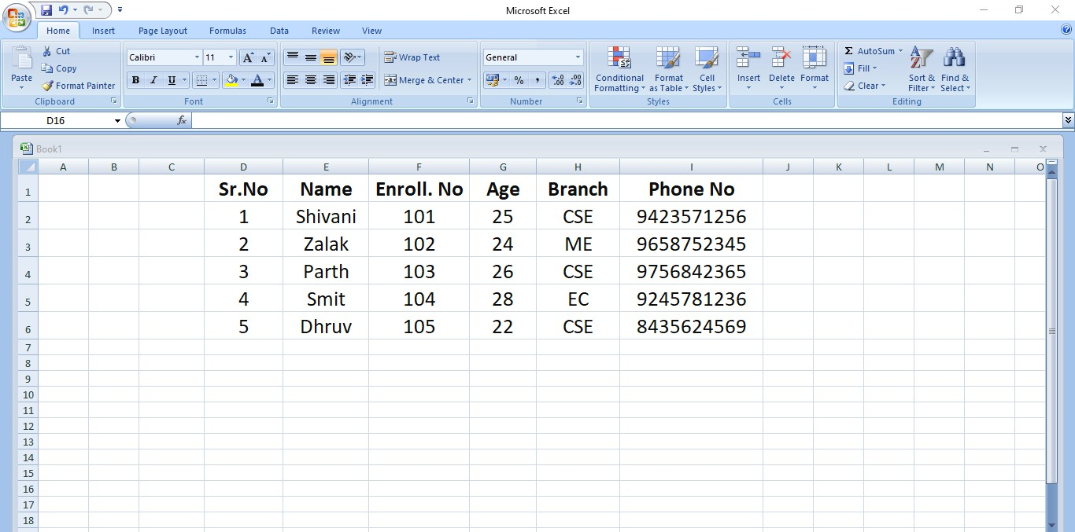

- Employee Details using MS Excel:

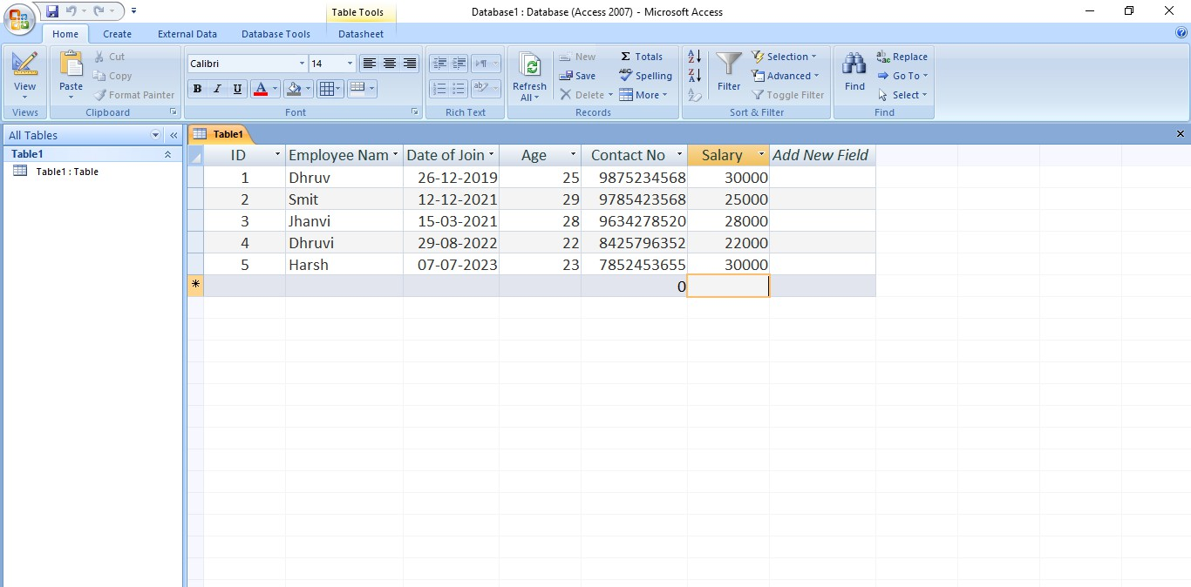

- Facebook using Excel:

